**LAPORAN TUGAS**

**ALGORITMA DAN STRUKTUR DATA**

**(Tabel Fungsi Matematik & Program Daftar Kode ASCI)**



Nama : Khofa Prayogo

NIM : L200150088

Kelas : B

PROGDI INFORMATIKA

UNIVERSITAS MUHAMMADIYAH SURAKARTA

1. **Tabel Fungsi Matematik**

|  |  |  |
| --- | --- | --- |
| 1 | acos(...)  acos(x) | Return the arc cosine (measured in radians) of x. |
| 2 | acosh(...)  acosh(x) | Return the hyperbolic arc cosine (measured in radians) of x. |
| 3 | asin(...)  asin(x) | Return the arc sine (measured in radians) of x. |
| 4 | asinh(...)  asinh(x) | Return the hyperbolic arc sine (measured in radians) of x. |
| 5 | atan(...)  atan(x) | Return the arc tangent (measured in radians) of x. |
| 6 | atan2(...)  atan2(y, x) | Return the arc tangent (measured in radians) of y/x.  Unlike atan(y/x), the signs of both x and y are considered. |
| 7 | atanh(...)  atanh(x) | Return the hyperbolic arc tangent (measured in radians) of x. |
| 8 | ceil(...)  ceil(x) | Return the ceiling of x as a float.  This is the smallest integral value >= x. |
| 9 | copysign(...)  copysign(x, y) | Return x with the sign of y. |
| 10 | cos(...)  cos(x) | Return the cosine of x (measured in radians). |
| 11 | cosh(...)  cosh(x) | Return the hyperbolic cosine of x. |
| 12 | degrees(...)  degrees(x) | Convert angle x from radians to degrees. |
| 13 | erf(...)  erf(x) | Error function at x. |
| 14 | erfc(...)  erfc(x) | Complementary error function at x. |
| 15 | exp(...)  exp(x) | Return e raised to the power of x. |
| 16 | expm1(...)  expm1(x) | Return exp(x)-1.  This function avoids the loss of precision involved in the direct evaluation of exp(x)-1 for small x. |
| 17 | fabs(...)  fabs(x) | Return the absolute value of the float x. |
| 18 | factorial(...)  factorial(x) -> Integral | Find x!. Raise a ValueError if x is negative or non-integral. |
| 19 | floor(...)  floor(x) | Return the floor of x as a float.  This is the largest integral value <= x. |
| 20 | fmod(...)  fmod(x, y) | Return fmod(x, y), according to platform C. x % y may differ. |
| 21 | frexp(...)  frexp(x) | Return the mantissa and exponent of x, as pair (m, e).  m is a float and e is an int, such that x = m * 2.**e.  If x is 0, m and e are both 0. Else 0.5 <= abs(m) < 1.0. |
| 22 | fsum(...)  fsum(iterable) | Return an accurate floating point sum of values in the iterable.  Assumes IEEE-754 floating point arithmetic. |
| 23 | hypot(...)  hypot(x, y) | Return the Euclidean distance, sqrt(x*x + y*y). |
| 24 | isinf(...)  isinf(x) -> bool | Check if float x is infinite (positive or negative). |
| 25 | isnan(...)  isnan(x) -> bool | Check if float x is not a number (NaN). |
| 26 | ldexp(...)  ldexp(x, i) | Return x * (2**i). |
| 27 | lgamma(...)  lgamma(x) | Natural logarithm of absolute value of Gamma function at x. |
| 28 | log(...)  log(x[, base]) | Return the logarithm of x to the given base.  If the base not specified, returns the natural logarithm (base e) of x. |
| 29 | log10(...)  log10(x) | Return the base 10 logarithm of x. |
| 30 | log1p(...)  log1p(x) | Return the natural logarithm of 1+x (base e).  The result is computed in a way which is accurate for x near zero. |
| 31 | modf(...)  modf(x) | Return the fractional and integer parts of x. Both results carry the sign of x and are floats. |
| 32 | pow(...)  pow(x, y) | Return x**y (x to the power of y). |
| 33 | radians(...)  radians(x) | Convert angle x from degrees to radians. |
| 34 | sin(...)  sin(x) | Return the sine of x (measured in radians). |
| 35 | sinh(...)  sinh(x) | Return the hyperbolic sine of x. |
| 36 | sqrt(...)  sqrt(x) | Return the square root of x. |
| 37 | tan(...)  tan(x) | Return the tangent of x (measured in radians). |
| 38 | tanh(...) tanh(x) | Return the hyperbolic tangent of x. |
| 39 | trunc(...)  trunc(x:Real) -> Integral | Truncates x to the nearest Integral toward 0. Uses the __trunc__ magic method. |
| 40 | gamma(...)  gamma(x) | Gamma function at x. |

1. **Script Program Daftar Kode ASCI dan Hasil Run program**

* 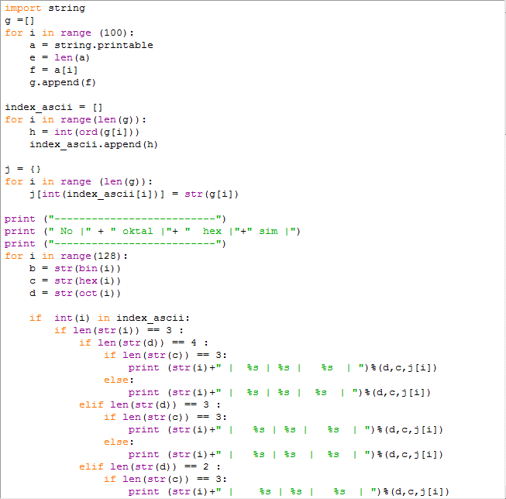Berikut adalah script program untuk menampilkan daftar kode ASCI :

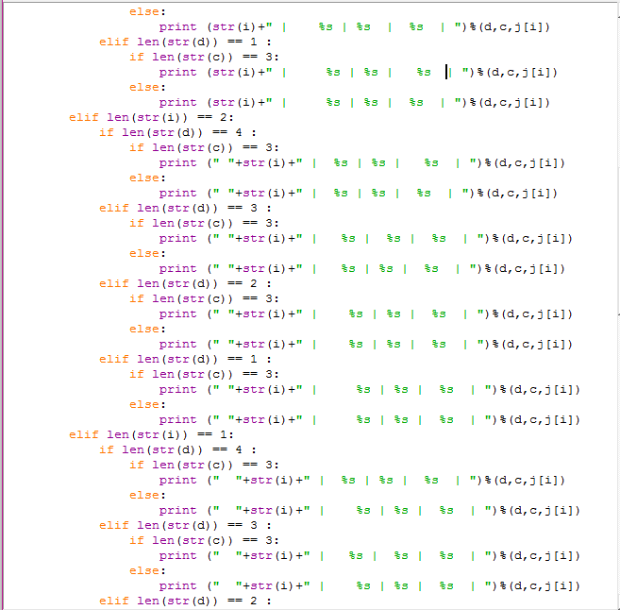

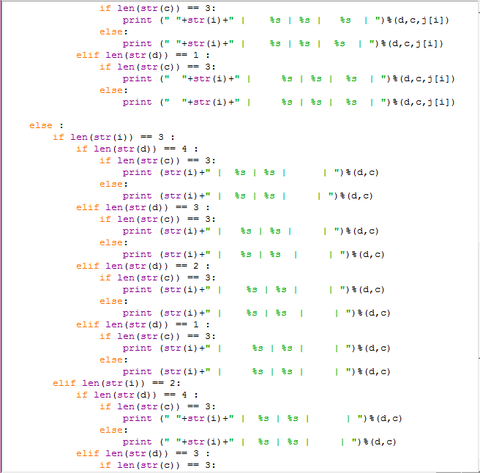

* Dan ini adalah tampilan script program asci yang sudah di run :

